# CS 255 System Design Document Template

This template lays out all the different sections that you need to complete for Project Two. Each section has guidance to prompt your thinking. You will need to continually reference the interview transcript as you work to make sure that you are addressing your client’s needs. There is no required length for the final document. Instead the goal is to complete each section based on what your client’s needs are. Remove this note when you are finished, and replace all bracketed text with the relevant information.

## UML Diagrams

### UML Use Case Diagram

[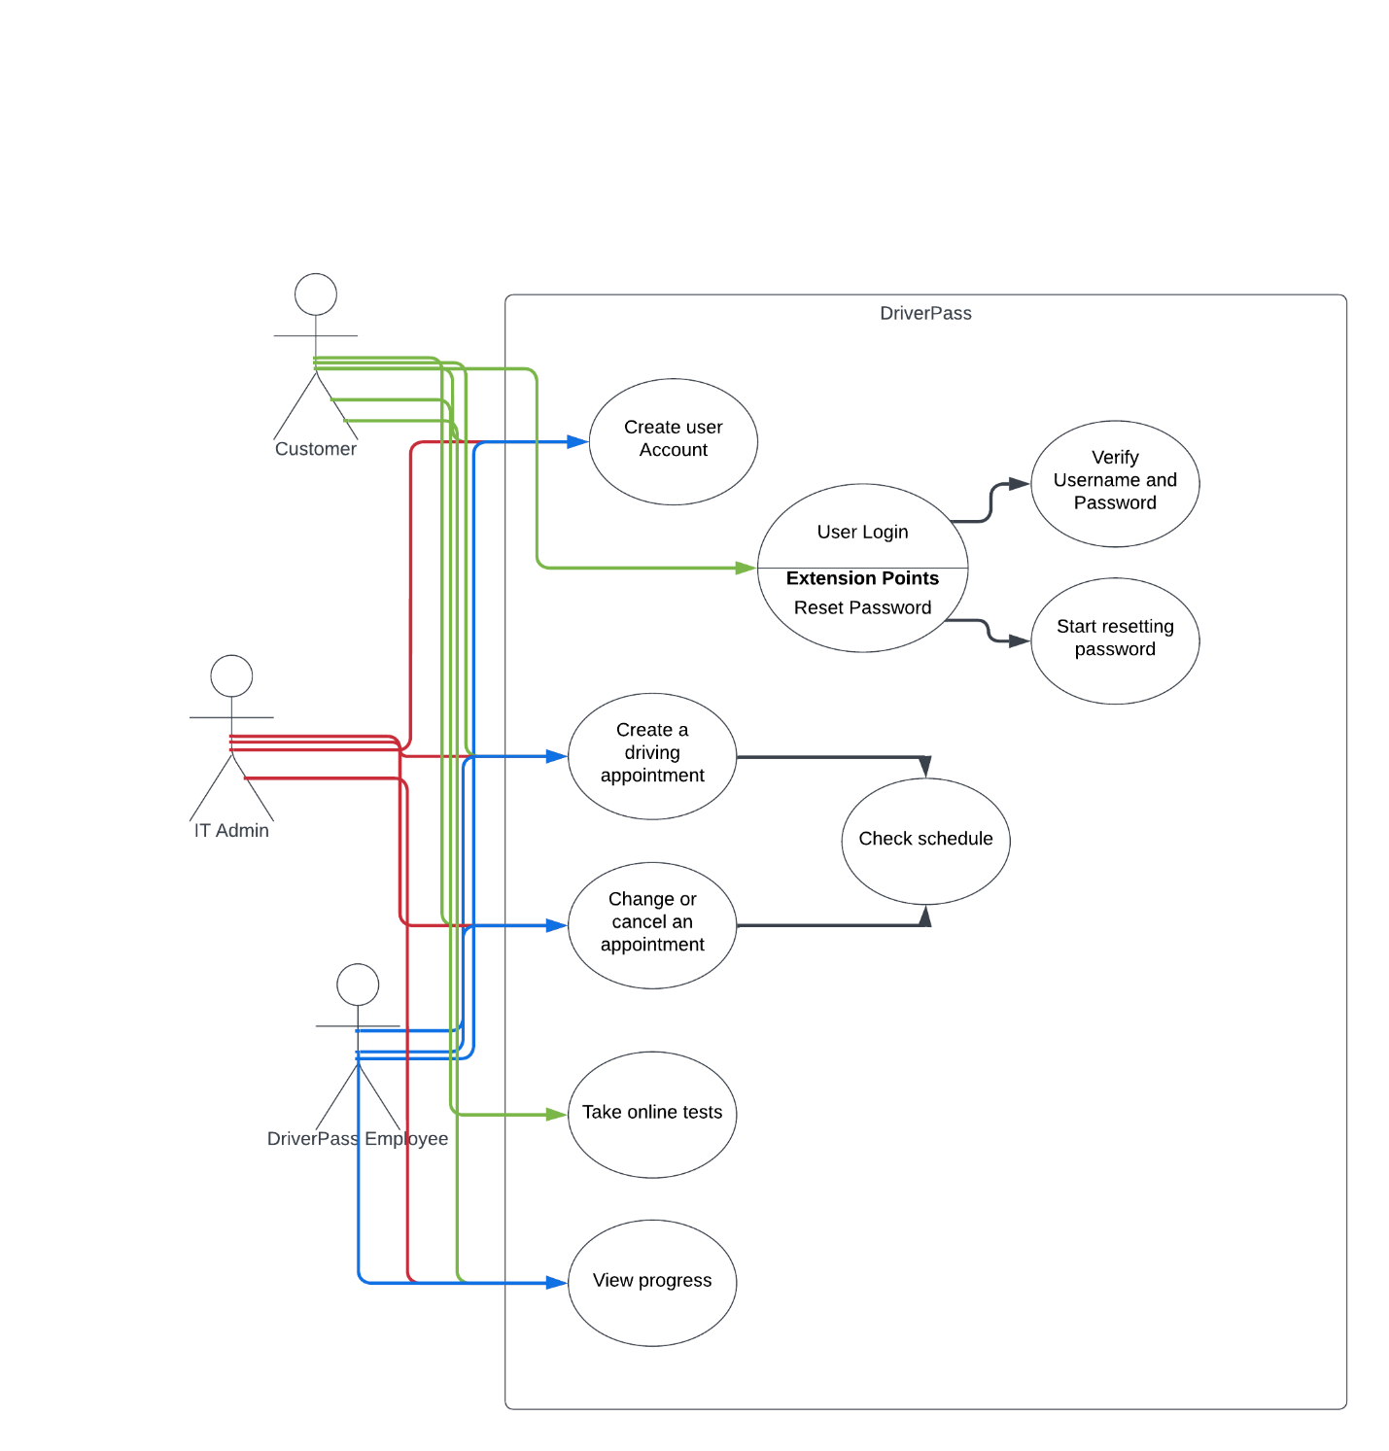](https://lucid.app/lucidchart/e2d93fe4-7faf-43c6-bdd8-5ffabb345c75/edit?crop=content&page=0&signature=b03d525be5e9ae32c33178e2dfeaec335a47471480112756edb90a07f7c906d7)

### UML Activity Diagrams

*[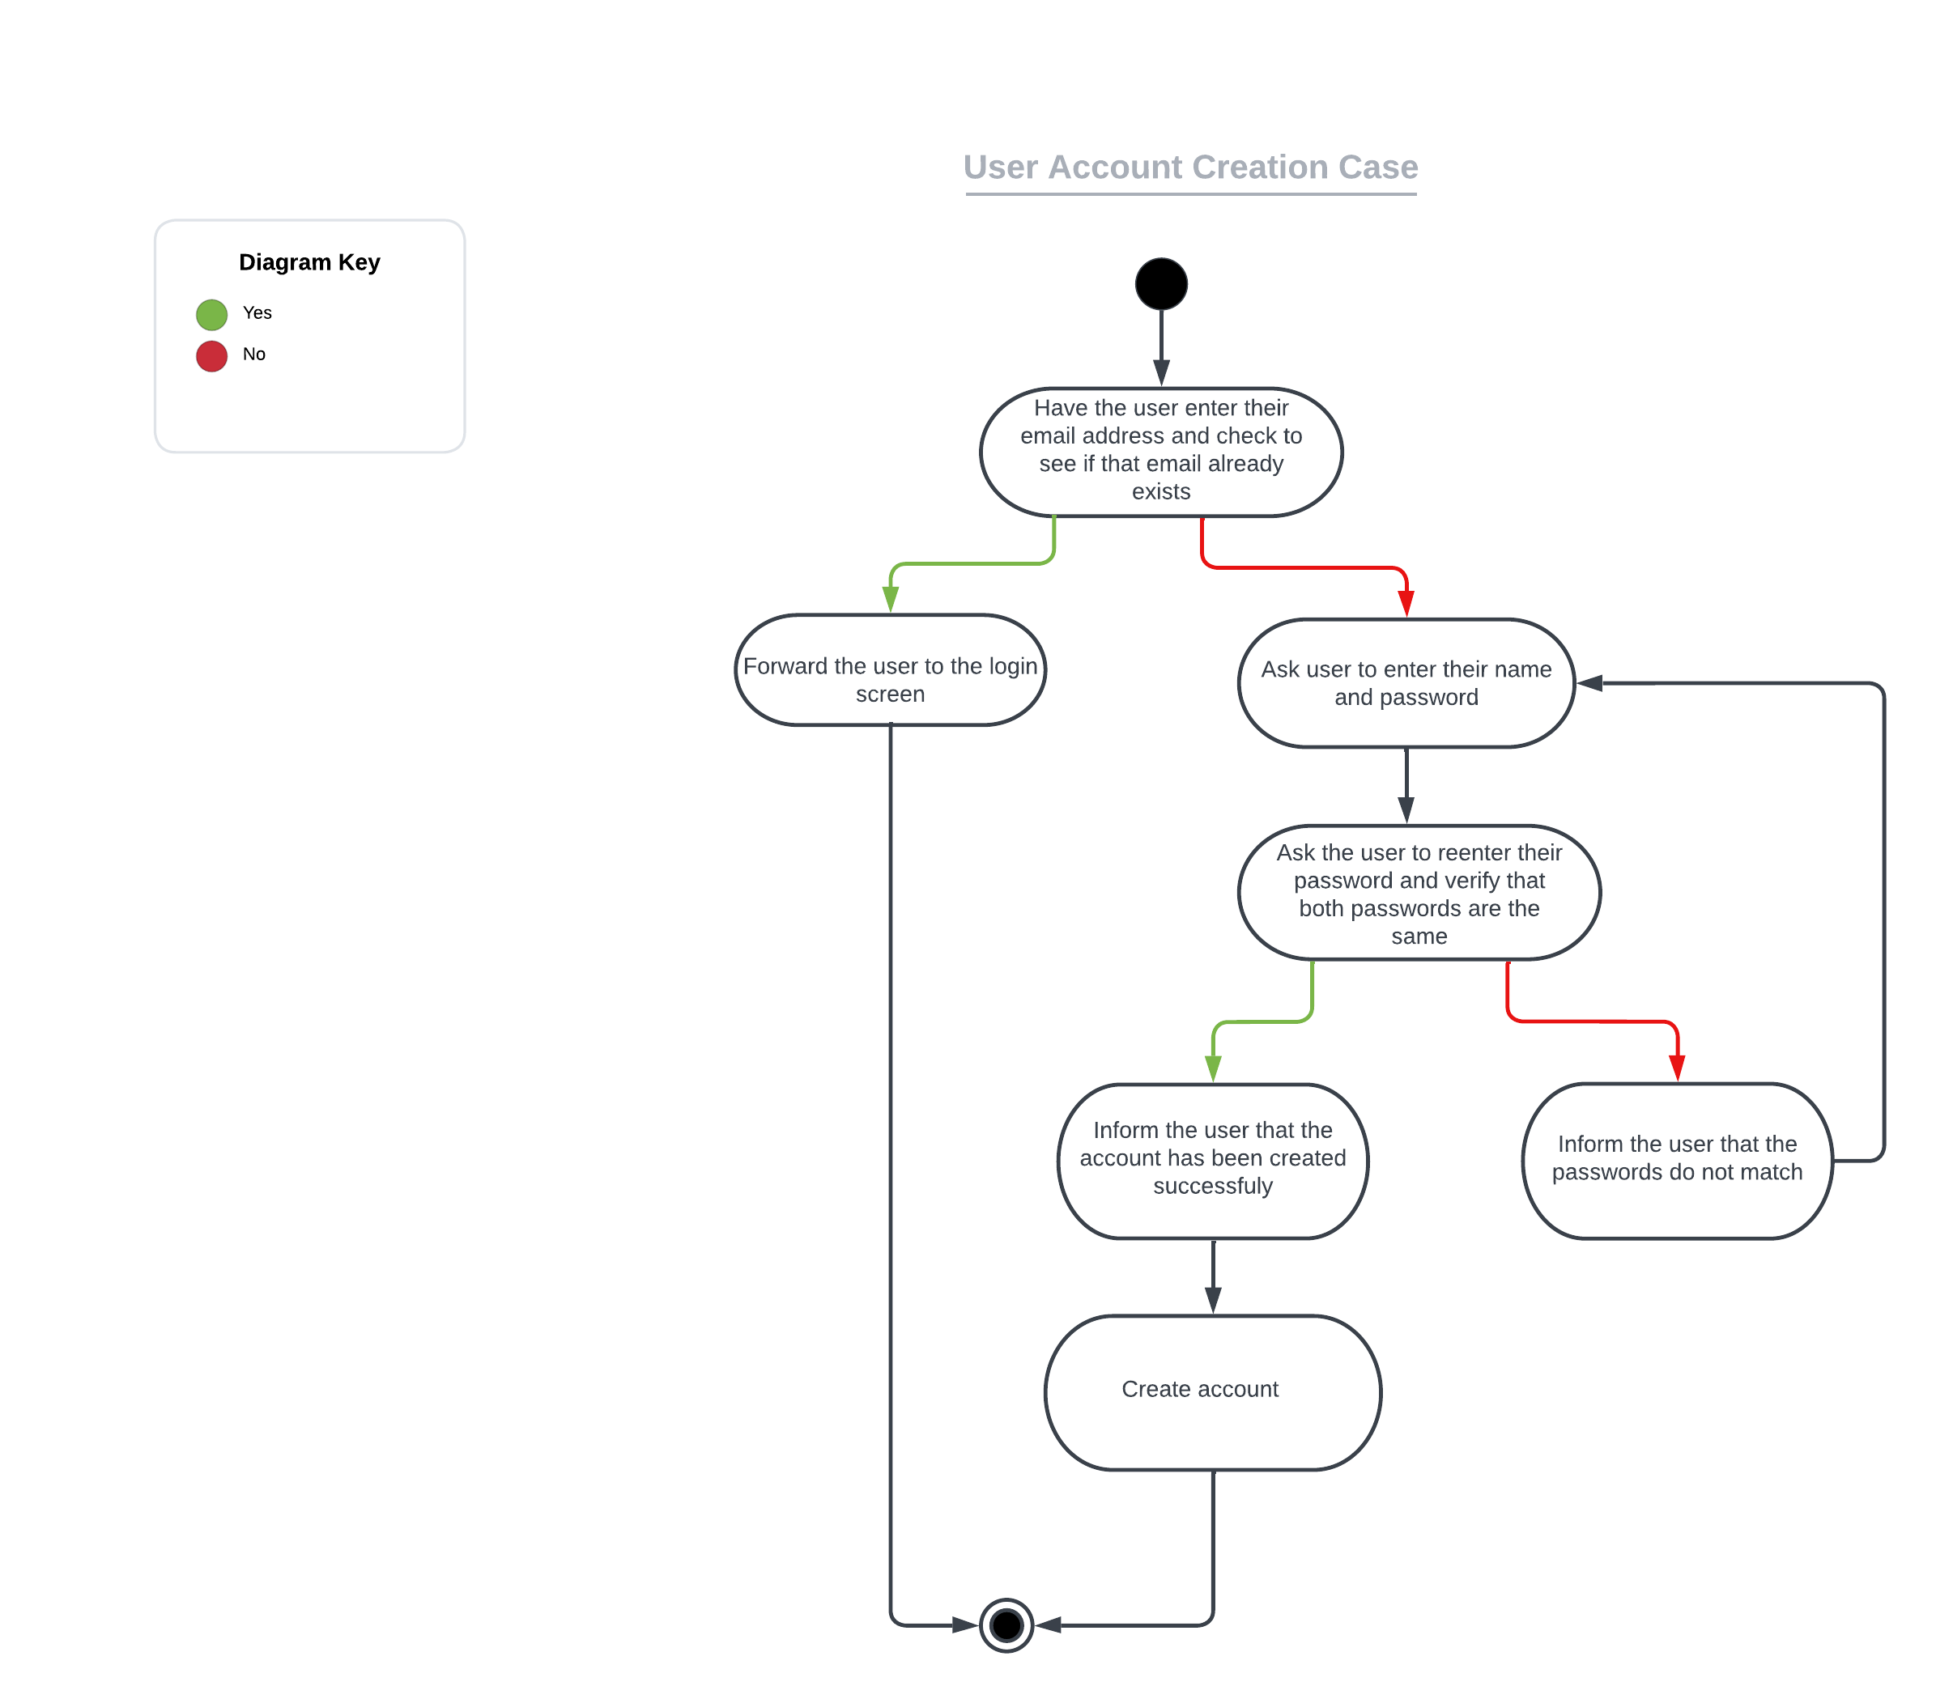](https://lucid.app/lucidchart/9b5e30a6-53a5-40f1-a9bd-3238adffc1a2/edit?crop=content&page=0&signature=c6cc7750c1066af5cd7b02b6954fffe36b95f0c8cf6937214f27af95304674ae)*

[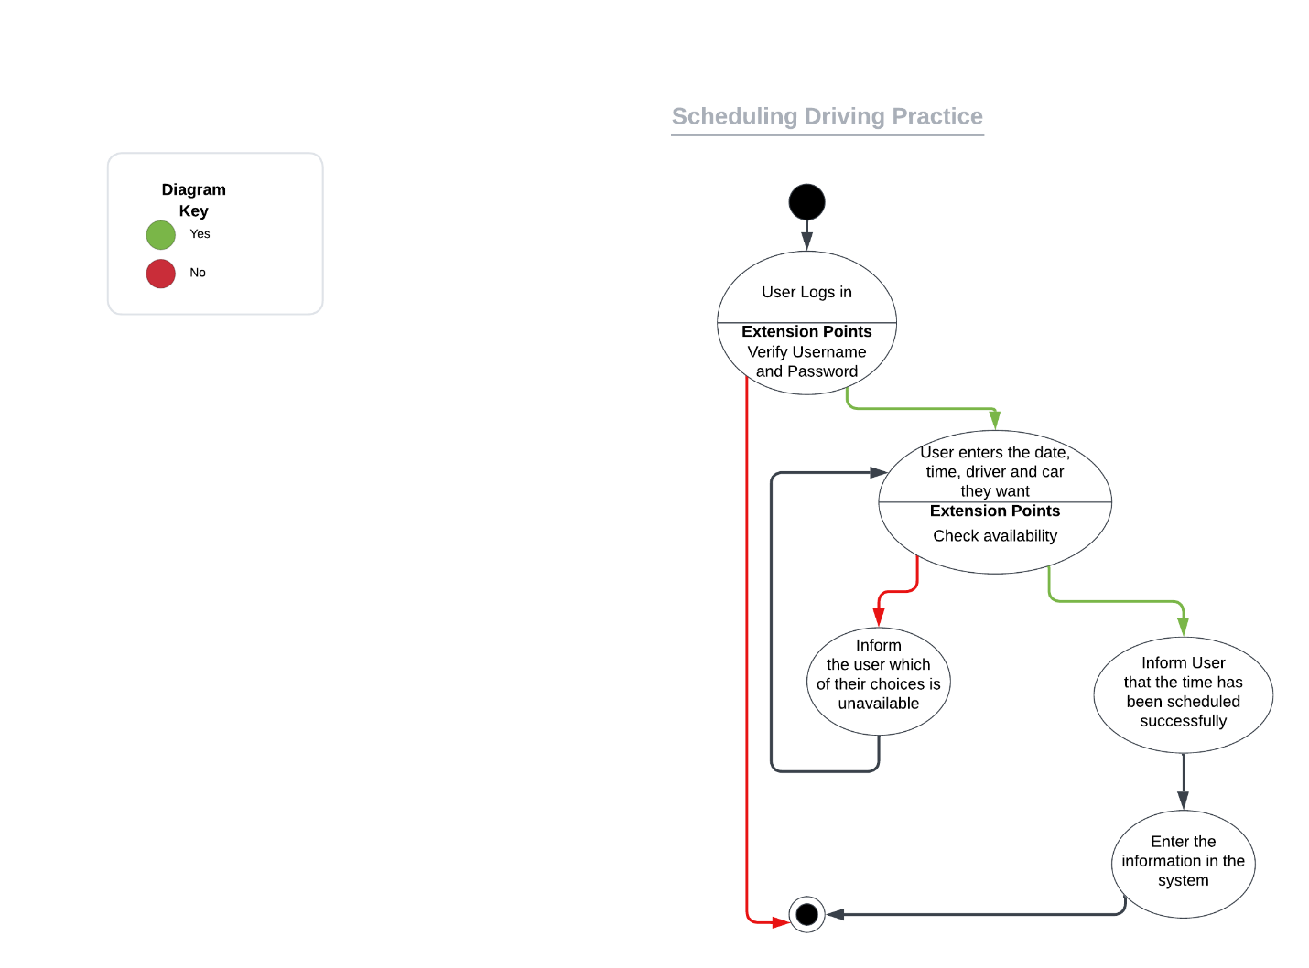](https://lucid.app/lucidchart/c4969b18-d3d3-4835-9ad5-e6ac4887dc74/edit?crop=content&page=0&signature=efd00c85763bd5e21d97ebd443a238cfedd28a89234ae244a659ceb2b9154538)

### UML Sequence Diagram

*[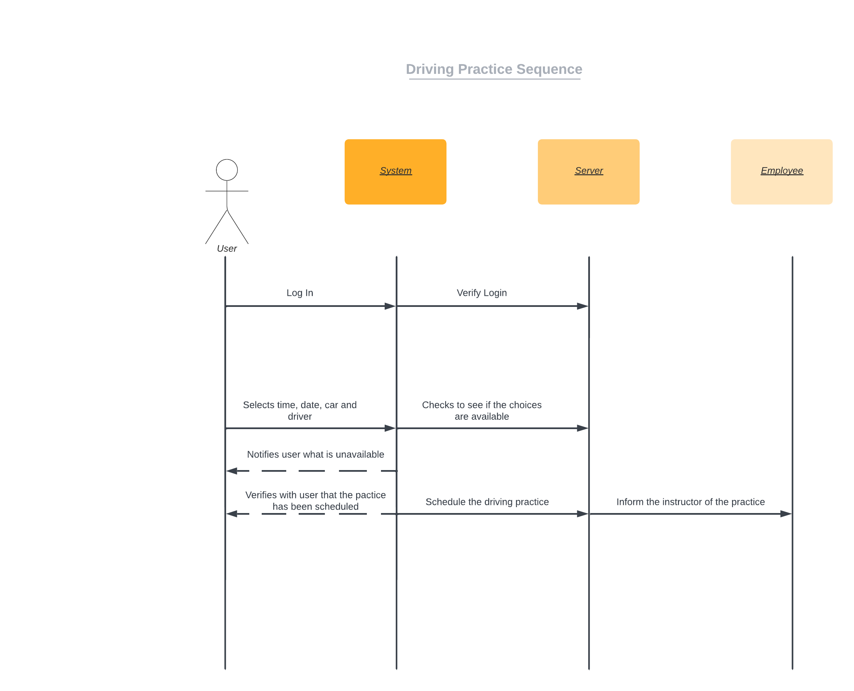](https://lucid.app/lucidchart/068535bb-288c-48d7-8f17-6d5b1c8b4a43/edit?crop=content&page=0&signature=1f9b8865cb300f3f62403ba8778446567452c7edeb4253dae8f2bbafceb317fe)*

### UML Class Diagram

*[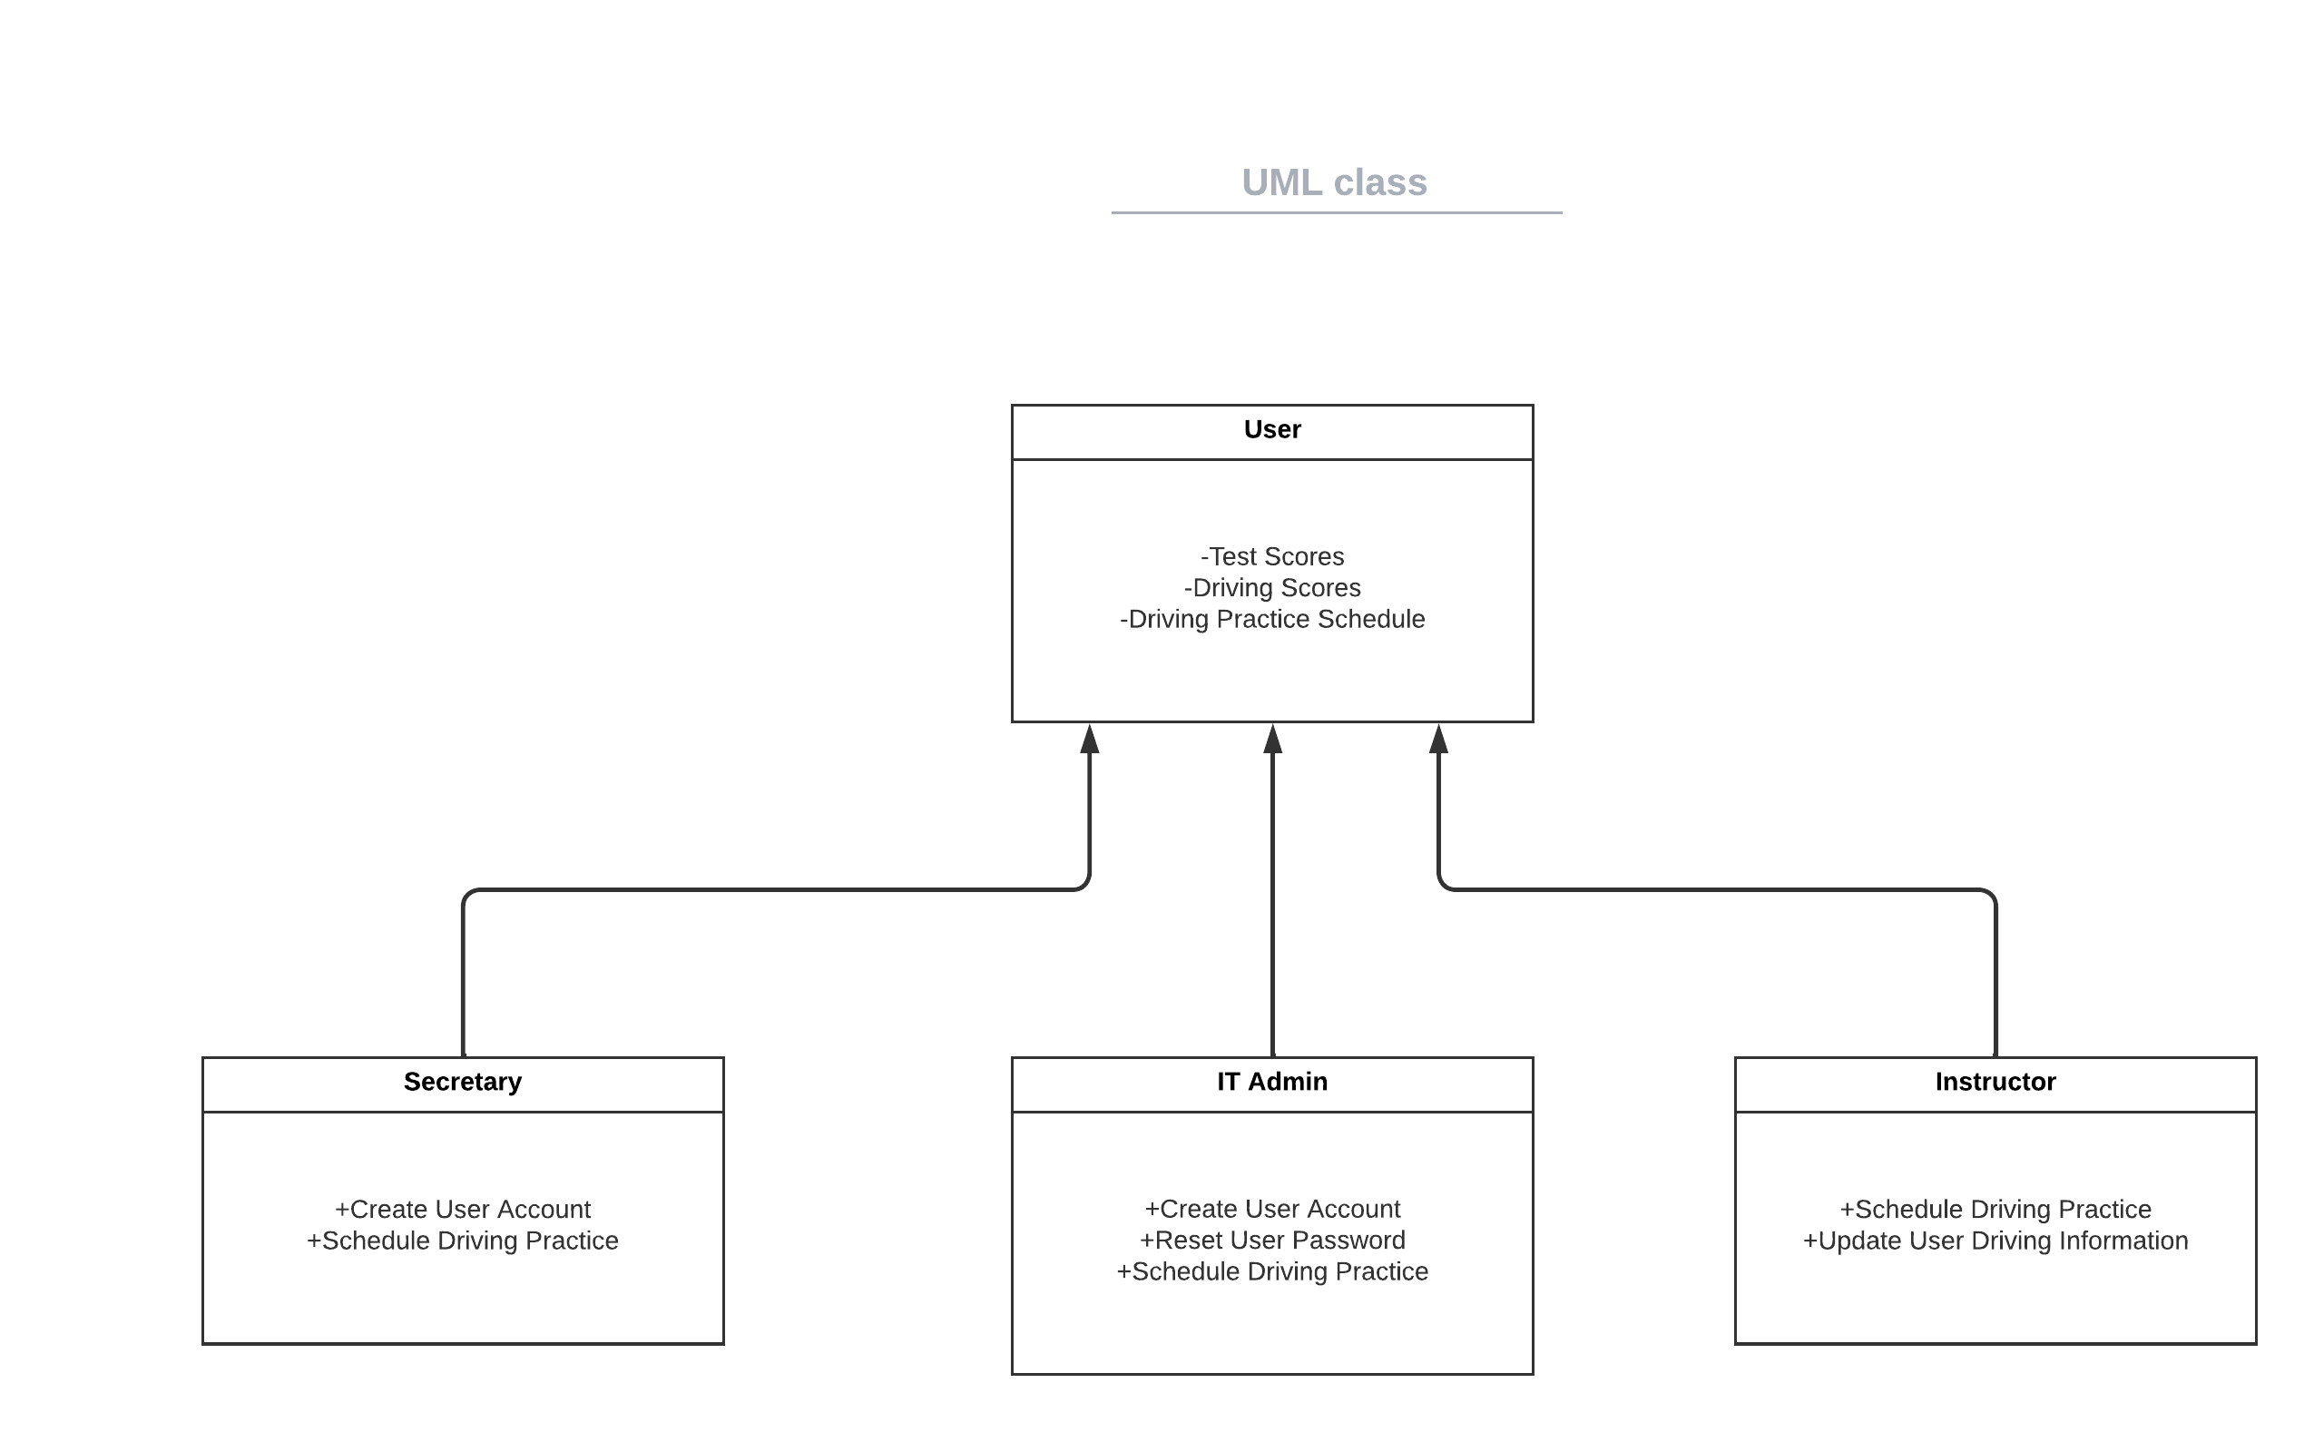](https://lucid.app/lucidchart/bdcd83d5-214d-4d62-a0e8-01be78262cf1/edit?crop=content&page=0&signature=8246200ded83f6e1c4031d289c35f1dc0313293254a705d73784fae89fa433d9)*

## Technical Requirements

To keep things as simple as possible and the hardware requirements to a minimum I suggest that the system use a cloud-based data center. By keeping the system on the cloud, it will require no extra hardware from the client and will be easily accessible and updateable. Software will need to be developed so the system will be able to run both on the web and on mobile applications. All the data that is transferred during use needs to be encrypted via SSL to ensure both data integrity and security. There will also need to be role-based access set up to ensure that only users that are authorized to do certain tasks will be allowed to do so. There will also need to be a log-in system set up where each user gets their own username and password which will only give them access to their account and the role that their account has been set up with. The passwords that users create will also need to have requirements put on them so that they are complex enough to not be easily hacked. For an added level of security two factor authentication should be offered to the users that want their accounts to be more secure.